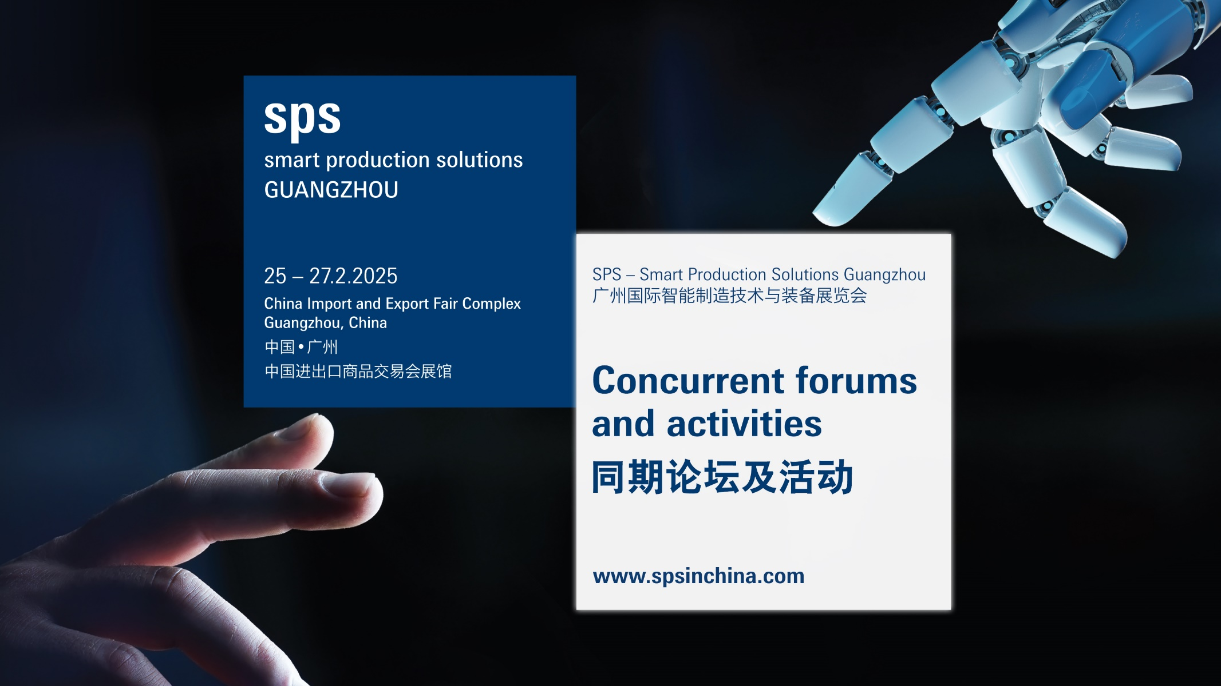

**SPS Guangzhou 2025 Concurrent Forums and Activities Schedule**

|  |  |  |  |  |
| --- | --- | --- | --- | --- |
|  | **5.1馆F53**  **Hall 5.1 F53** | **5.1馆B55**  **Hall 5.1 B55** | **4.1馆****G49**  **Hall 4.1 G49** | **4.1馆A27**  **Hall 4.1 A27** |
| **Day 1: Tuesday, 25 February 2025** | | | | |
| **上午**  **A.M.** | 主论坛：可持续制造业的数字化转型高峰论坛  Main Forum:  Digital Transformation for Sustainable Manufacturing Summit | 广东省测量控制技术与装备应用促进会、广州市仪器仪表学会青年委员会成立暨学术研讨会  The Founding Congress of Youth Councils and Academic Conference of Guangdong Measurement and Control Promoted Association, and Guangzhou Instrument and Control Society | 2025年工业工程精益数智化改善大会（广州站）  2025 Industrial Engineering Lean Digitalization Intelligent Improvement Conference (Guangzhou) | 机器人+ 赋能产业发展  Robot plus, Empowering Industrial Development |
| **下午**  **P.M.** | 第二届机器人与智能传感技术高峰论坛  The 2nd Robot and Sensor Technology Summit |
| **Day 2: Wednesday, 26 February 2025** | | | | |
| **上午**  **A.M.** | 第四届中国数字工厂推进大会  The 4th Digital Factory Congress (DFC) | 迎接日本制造业的未来  IIFES（日本测量技术展）  合作论坛  Manufacturing Meets the Future in Japan  Cooperation conference with IIFES | 新型工业化下的人形机器人与具身智能发展论坛  Humanoid robots and Embodied AI Development in New Industrialization Era Conference | 汽车行业智能制造高质量发展论坛  High Quality Development of Intelligent Manufacturing in Automotive Industry Forum |
| **下午**  **P.M.** | 世界制造业基金会论坛  未来制造业新视野：  从全球视野展望2030  World Manufacturing Foundation Forum:  The Future of Manufacturing:  Outlook 2030 and International Perspectives | OPC UA 助力推动制造业智能化发展  OPC UA drives manufacturing intelligence | AI与自动化驱动的制造业数字化转型  Digital Transformation of Manufacturing Driven by AI and Automation |
| **Day 3: Thursday, 27 February 2025** | | | | |
| **上午**  **A.M.** | 驱动之芯，智控之道- 2025 智能控制与驱动发展论坛  The Core of Drive and the Way of Intelligent Control | 机器视觉与自动化：  解锁智能工厂的核心能力  Machine Vision and Automation:  Unlocking the Core Capabilities of the Smart Factory | 一开始就正确  - 数字仿真与AI智能塑造领先生产力  合作单位：MTM中国  First Time Right  - Virtual Planning and Digital Intelligence Shape Leading Productivity  Cooperation: MTM China | 制造业出海的机遇和风险  The Opportunity and Challenge for Manufacturing Industry Going Global |